Shell Case Work

Emp name: Akshita Verma

Emp ID: 655167

**AZURE BOARD ACTIVITIES**

1)Project

2)Epic

3)Product backlog

4)Sprint Backlog

5)User stories

6)Tasks

7)Test cases

8)Bug

9)Azure board taks and sprint closure

**AZURE VM creation**

**GITHUB ACTIVITIES**

Git installation

Git clone

Git pull request

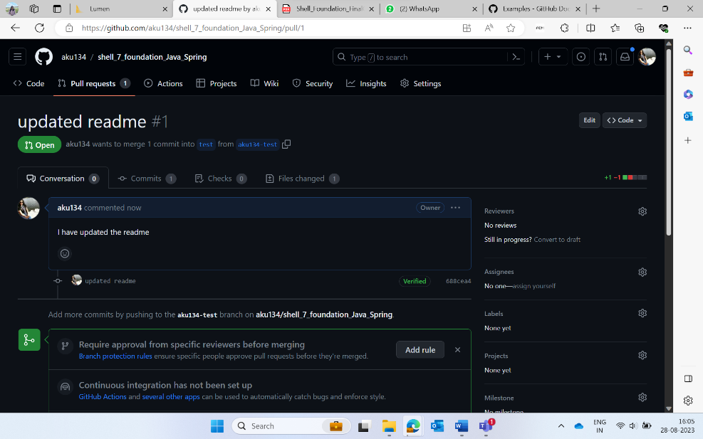

Create Fork

**MAVEN ACTIVITY**

Maven installation

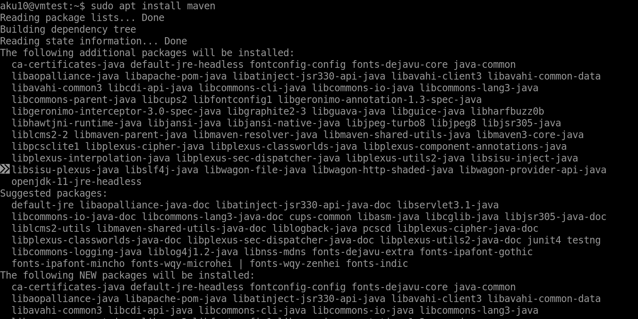

Maven Build Process

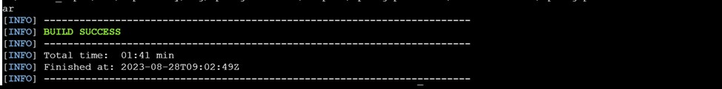



**PROMETHEUS ACTIVITY**

**DOCKERFILE CREATION**

Build and push to repository

Image pushed to docker hub repository

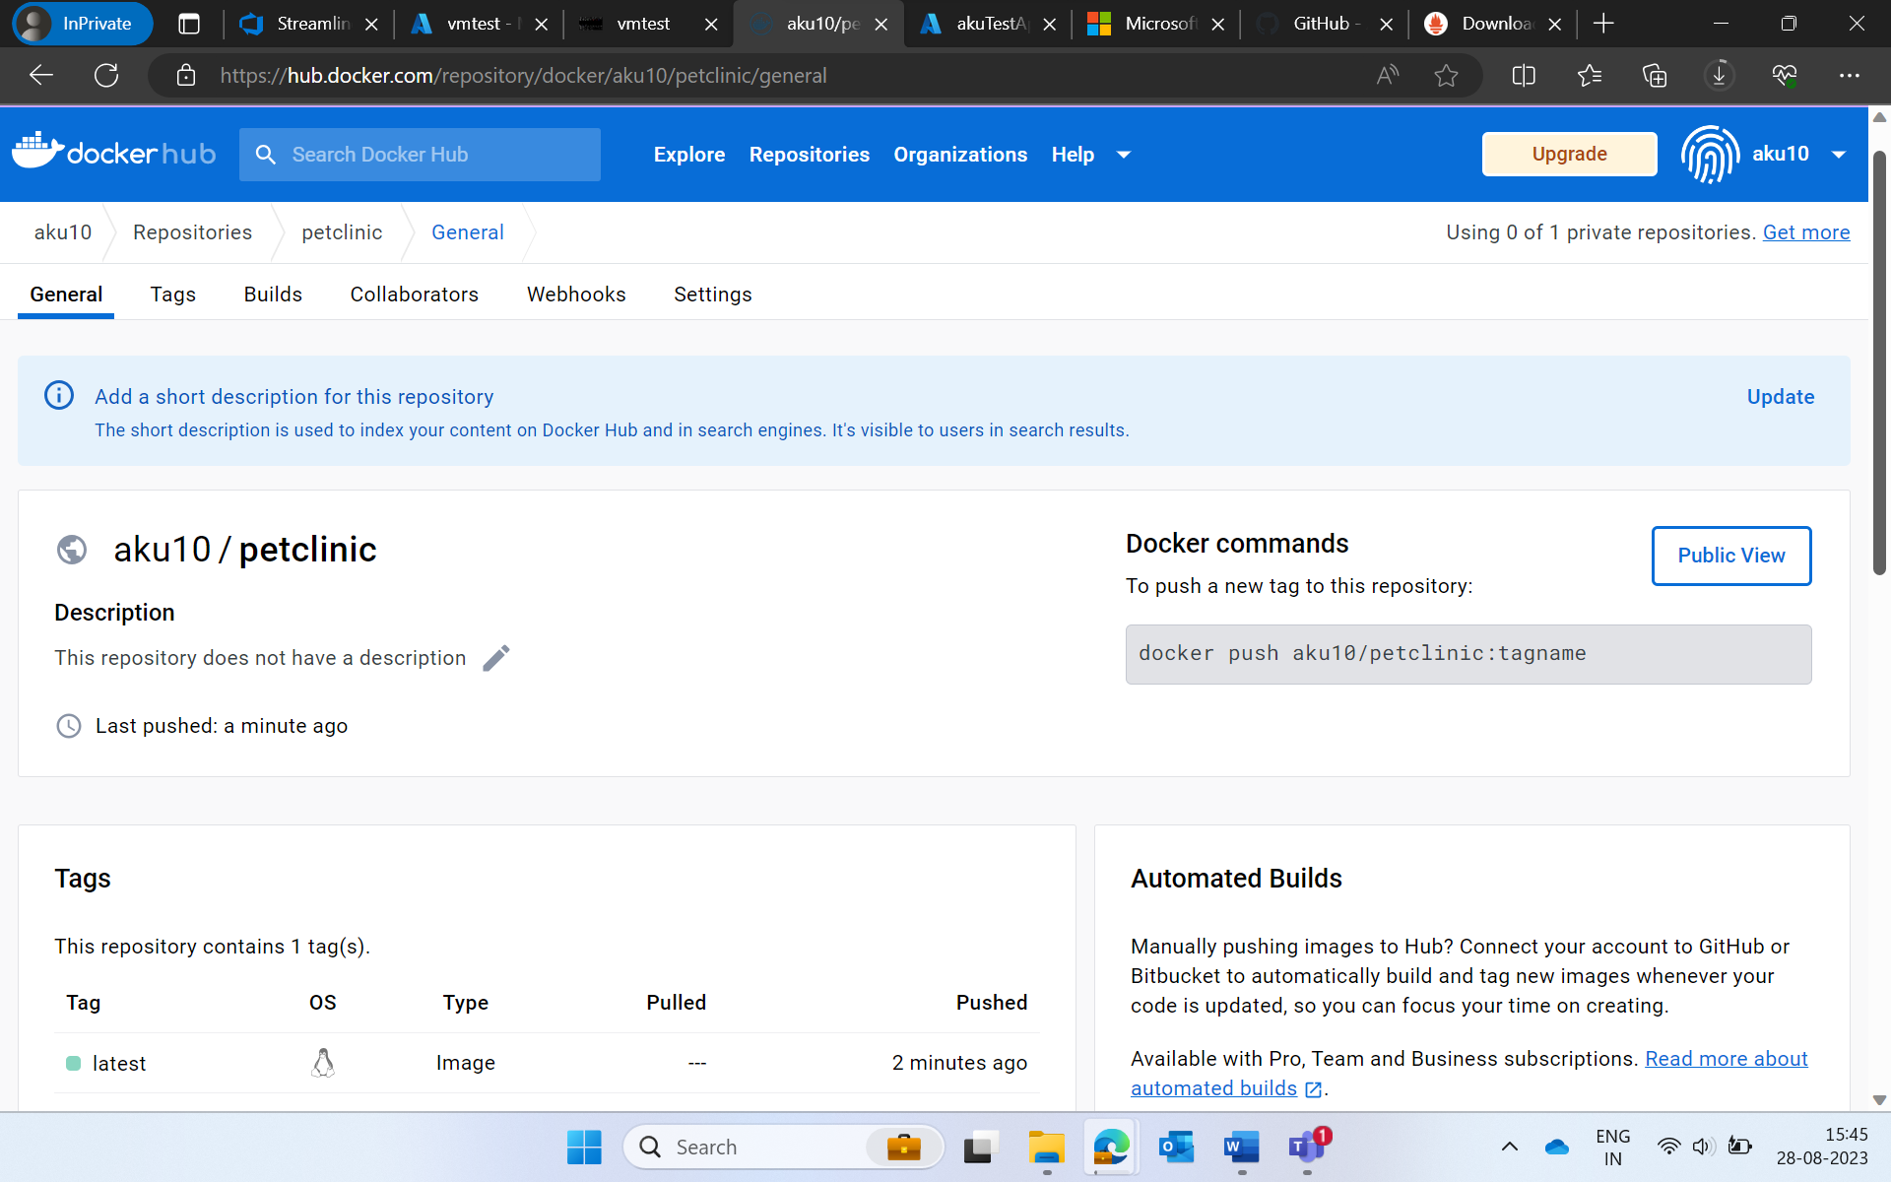

**GITHUB ACTIONS**

AZURE WEB APP CREATION AND DEPLOYMENT

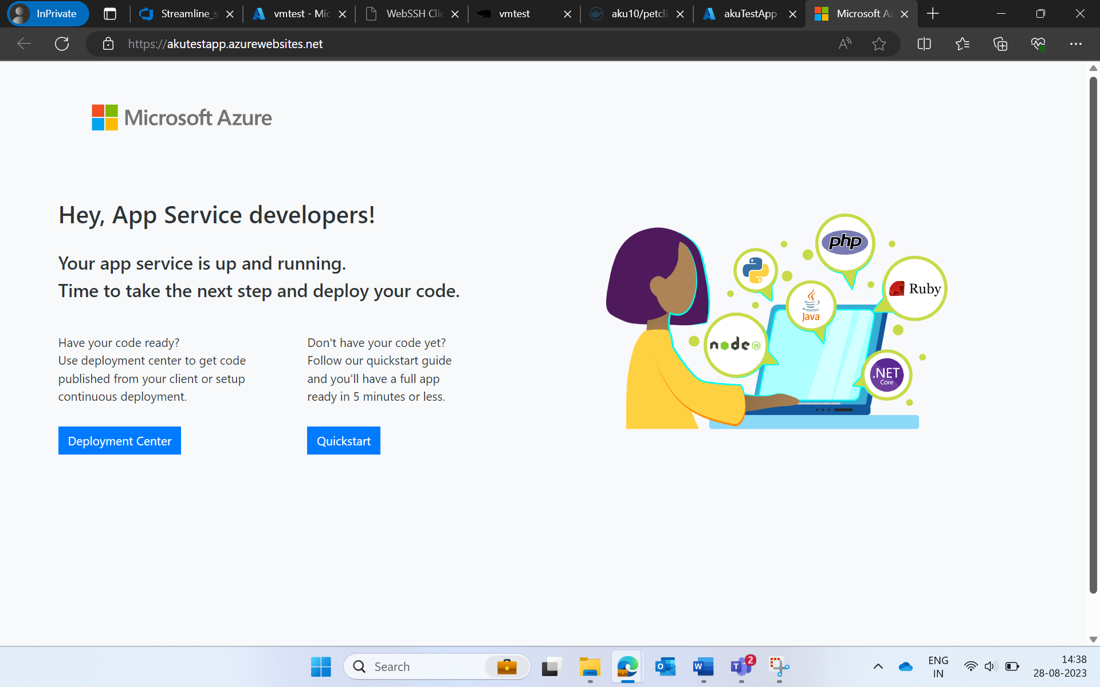

**Lessons Learnt**

* Creating and managing tasks, user stories, epics etc on Azure boards.
* Learnt how to perform github activities such as git clone,
* git push, pull request etc
* Creation of VM on Azure and allocating resources
* Installation of maven
* Docker installation and creation – build ,push
* Performing Github actions such as creating triggers on push, pull
* Prometheus monitoring tool.
* Creating web app on Azure portal